What is Graph QL ?
GraphQL is a query language for APIs and a runtime for executing those queries with your existing data. It was developed by Facebook in 2012 and open-sourced in 2015.

GraphQL Architecture
- Client sends query to the server.
- GraphQL Server parses query, validates it against schema.
- Resolver functions fetch/compute the required data.
- Result is sent back in the exact shape client requested.

Benefits of GraphQL
Feature | Benefit
Single endpoint | Avoids REST's multiple endpoints.
Client-specified data | Reduces over-fetching and under-fetching.
Strongly typed | Schema validation, introspection.
Tooling support | Tools like GraphiQL, Apollo Studio, Postman.
Versionless API | Schema evolution without breaking clients.

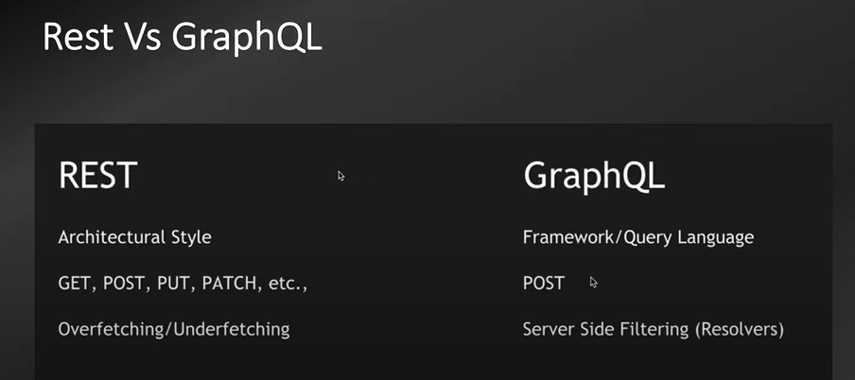

Benefits of GraphQL
Feature | Benefit
Single endpoint | Avoids REST's multiple endpoints.
Client-specified data | Reduces over-fetching and under-fetching.
Strongly typed | Schema validation, introspection.
Tooling support | Tools like GraphiQL, Apollo Studio, Postman.
Versionless API | Schema evolution without breaking clients.

